INDIAN INSTITUTE OF TECHNOLOGY, BOMBAY

**Department of Metallurgical Engineering and Materials Science**

**MM 209: THERMODYNAMICS : 2019-20: Fall**

**Assignment 1 Submission Date: 02 Aug 2019; 0830h**

NOTE: 1. All submissions are individual, and should be unique. Copy, even with language cursorily changed, from others (including from the internet) is plagiarism.

2. Assignments are submitted in both **soft copy** and **hard copy**. Soft copy is to be submitted in the moodle, which is a back-up in case the hard copy gets lost. Take a camera copy before hard copy submission. The hard copy should please be submittted in A4 sheets, during the class on the date mentioned above. Remember that when you accept the assignment sheet, it is a contract between you and me.

3. **This assignment is for ideating, creative thinking, and *setting the right mood* for the course. It tells you the kind of problems you can solve on completion of the course. Hence do not look up references and do not discuss with others before turning in this assignment. Correct answers do not matter. The thought processes and developing an attitude for analysis are all that is important.**

**____________________________________________________________­­_______________**

1. We have been working on an interesting process for making iron, in which iron ore is reduced to iron in a low shaft mud furnace. ‘The heat and the reductant are provided by burning charcoal in the furnace, with the help of atmospheric air blown through a clay tube attached to the side wall near the bottom. Iron is obtained, after five to six hours of back- breaking work on the kettle drum bellows, as a lump of porous solid at the bottom of the furnace. This process is practiced by *Agarias*  in the remote parts of the tribal belts of Chhattisgarh, M.P., and probably Bihar, till recently. *We built this furnace at IITB (actually two BTPs), and did some experiments on it to understand the science behind the process.*

Now we have been having an argument amongst ourselves regarding the way this process works. One opinion is that the reduction takes place completely in the solid state. No liquefaction of iron takes

place anywhere in the furnace, because it is not possible to attain the kind of temperature necessary to melt iron (1530oC) by blowing cold air into burning charcoal. The other group

however disagrees. One can achieve, it opines, high enough temperature to melt iron; one needs only to blow air at a fast rate. More energy produced, higher is the temperature. By looking at the product we are not able to tell who is right. Can you help us (you have learnt so much of science after all!) and tell how to go about resolving this problem?

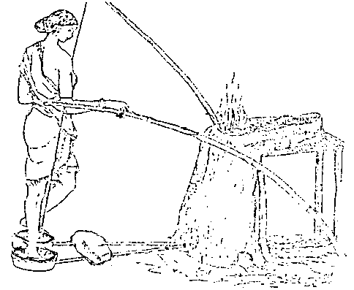

No it isn’t possible for Iron to melt using just charcoal even if the air is too fast there’s a limited surface area of charcoal that’s coming in contact with air, and hence the limit to the amount of energy produced.

1. Have you ever noticed the thin fog that gathers around at the mouth of champagne or a soda bottle just after it has been opened? What causes the fog?
2. In the tungsten filament lamps, tungsten slowly evaporates from the filament, and ultimately the bulb will ‘fuse’. I am told that if you put a little bit of chlorine into the bulb, you can reverse this process and increase the life to the lamp. Can you tell me how this takes place and why?
3. The night vision cameras have a thin film of Hg0.22Cd0.78Te deposited on a substrate. One of the methods to produce this is the liquid phase epitaxy where a liquid phase consisting of HgTe and CdTe is held over the substrate and slowly cooled. If the composition of the liquid is right, an *epitaxial* layer of the right composition grows on the substrate. Can you help in deciding the liquid composition? Should it be the same as the solid composition ?
4. One would like to produce silicon nitride from the inexpensive raw materials like: silica sand. I am told one needs to have a reductant like carbon/CO along with nitrogen to produce silicon nitride. But I am afraid that silicon carbide may form instead of the nitride. Can you tell me a way to avoid this?
5. Why are mountain tops cold ? Isn’t the solar heat per unit area on a mountain about the same as at sea level ? Why is there a tree-line above which few trees grow in the mountains ? [ J Walker]
6. We all agree that the boiling point of water is 373.13K. What exactly happens at this temperature? After all, water-to-vapor reaction takes place at lower temperatures too (cloth does dry at room temperature, doesn’t it?). Inside the pressure cooker, the manufacturer claims, the water does not ‘boil’ below about 400K. Can you explain? Can you give some numbers ?
7. 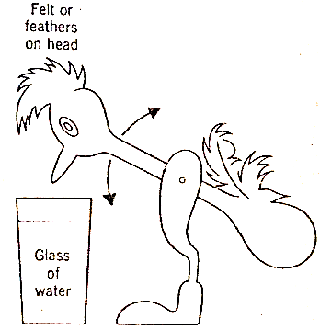If you put some salts, like ammonium chloride, into water, the solution cools down? Why? Don’t I have to do some work, like in a refrigerator, to cool anything?
8. 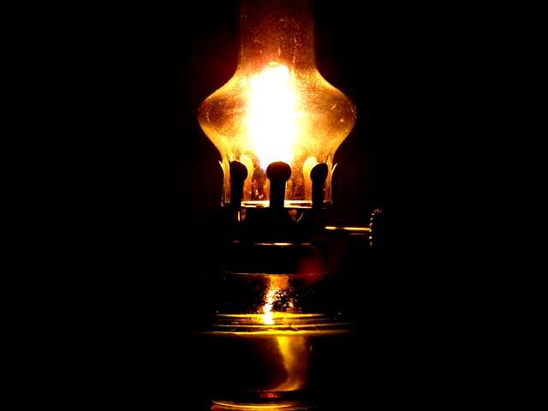Have you seen this common toy in shop windows ? It is a glass bird which rocks back and forth, and, once in a while, dunks and ‘drinks’ water from the glass. Thereafter it becomes upright again and continues to rock. And the process goes on *ad infinitum* (?). How does it work ? Does it violate the principle of energy conservation ? (Figure from *J.Walker: Flying Corcus*).
9. Why is there soot formation in the upper part of the glass covers in the kerosene burning lamps ? You rarely get soot on the vessel kept on the gas stove in your mother’s kitchen, isn’t it?
10. You have learnt that the freezing point of water is 0° C and boiling point is 100° C. How accurate are these values? Can I, for example, say that the boiling point is 100.00000000° C? Will the values changes in future when the accuracy of measurement increases?
11. When one is ice-skating, why do your skates slide on the ice surface? Can you explain the why of the physical law involved? Can you give some numbers and show whether it can be too cold to skate? Can you skate on frozen carbon dioxide? Why? (From J. Walker).
12. I want to heat a polished piece of steel to a high temperature, say 1000K. I am afraid that the surface will get badly oxidized if the furnace atmosphere is air. People suggest that I use a gas atmosphere containing a mixture of CO and CO2. But I have seen that such gas mixtures can sometimes deposit carbon particles ruining my sample surface (remember lamp black). I have to have the right mixture of these two gases. Can you advise me as to what I should do to find the right composition?

Recap basic maths :

1. Which of the following are not exact differentials ?
   1. dz = 3x2y2 dx + 2 x3ydy
   2. dz = y4 + 3xy3
2. For a function F(x,y,z) = 0, can you show that

${\left(\frac{∂x}{∂y}\right)}_{z}=1/{{\left(\frac{∂y}{∂x}\right)}_{z}}$

${\left(\frac{∂x}{∂y}\right)}_{z}=−{\left(\frac{∂x}{∂z}\right)}_{y}.{\left(\frac{∂z}{∂y}\right)}_{x}$

${\left(\frac{∂x}{∂y}\right)}_{p}=$ ${\left(\frac{∂x}{∂z}\right)}_{p}.{\left(\frac{∂z}{∂y}\right)}_{p}$

----------------------------------------------------------------------------------------------------

**Some important tips:**

* The assignment given here is designed to tell you the kind of problems a materials engineer is often asked to solve. The solutions beg knowledge of thermodynamics. You may not be able to solve them completely at the beginning of the course. Try solving them anyway, so that at the end of the course you can decide for yourselves the progress that you have made.
* You are advised to solve all the problems first in general symbols, whenever possible, so that dimensional correctness can be checked. It is also advisable to insert numerical values with units to verity consistency of units, especially if you are not strictly adhering to SI units. Use of the standard SI units is always beneficial since this avoids all conversion factors. Therefore study SI units carefully with all its conventions. It will be useful in future.

(http://en.wikipedia.org/wiki/International_System_of_Units)